According to Intelli, the Finland respiratory devices market was valued at USD 8986 million in 2024 and is expected to reach USD 13894.57 million by 2032, growing at a CAGR of 6.5% from 2024 to 2032.

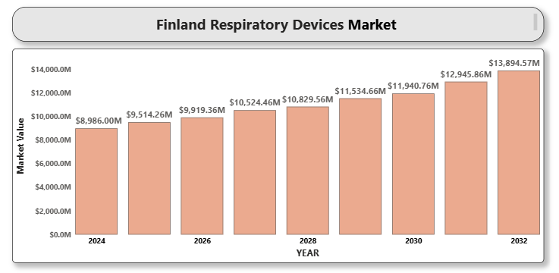

Finland's respiratory devices market is witnessing steady growth due to a rising prevalence of respiratory diseases such as asthma, COPD, and sleep apnea. A growing aging population, increasing pollution levels, and heightened awareness about respiratory health are driving demand. The healthcare system's efficiency and Finland's proactive approach toward adopting innovative medical technologies further support market development.

**Finland Respiratory Devices Market Definition**

Respiratory devices include diagnostic and therapeutic tools used to monitor and manage respiratory disorders. These range from inhalers and nebulizers to oxygen concentrators, ventilators, CPAP devices, and spirometers. The market encompasses both home care and hospital-based equipment aimed at improving pulmonary function and respiratory therapy outcomes.

**Finland Respiratory Devices Market Overview**

The market in Finland is benefiting from the digitalization of healthcare, increased government investments in public health infrastructure, and the shift toward home-based care. The COVID-19 pandemic accelerated ventilator demand, and there's a sustained focus on preparedness for respiratory disease outbreaks. However, reimbursement issues and high device costs pose certain challenges.

**Finland Respiratory Devices Market Segmentation Analysis**

**Market Segmentation by Product Type:**

* Therapeutic Devices
  + Inhalers (Metered Dose and Dry Powder)
  + A close-up of hands holding a tablet and a pen

    Description automatically generatedNebulizers
  + Oxygen Concentrators
  + Ventilators
  + CPAP and BiPAP Devices
* Monitoring Devices
  + Pulse Oximeters
  + Capnography Devices
* Diagnostic Devices
  + Spirometers
  + Peak Flow Meters

Therapeutic devices dominate the market due to the widespread incidence of chronic respiratory conditions. Oxygen concentrators and CPAP devices are seeing high adoption in both hospital and home settings.

**Market Segmentation by Indication:**

* Asthma
* Chronic Obstructive Pulmonary Disease (COPD)
* Sleep Apnea
* Respiratory Infections
* Others

COPD and sleep apnea constitute the majority of indications due to their increasing prevalence in Finland's aging demographic.

**Market Segmentation by End User:**

* Hospitals
* Home Healthcare
* Ambulatory Surgical Centers
* Clinics

Home healthcare is growing rapidly due to the increasing emphasis on comfort, cost-effectiveness, and patient preference for treatment outside hospitals.

Market Segmentation by Region:

* Southern Finland
* Western Finland
* Northern and Eastern Finland

Southern Finland leads due to urban concentration, availability of advanced healthcare facilities, and awareness levels. Government initiatives are expanding access in rural northern and eastern areas.

**Key Players**

Prominent companies in the Finland respiratory devices market include Philips Healthcare, ResMed Inc., Medtronic plc, Drägerwerk AG & Co. KGaA, Fisher & Paykel Healthcare Corporation Limited, GE HealthCare Technologies Inc., Vyaire Medical Inc., Masimo Corporation, and Invacare Corporation.

**Key Developments**

* In 2024, Finland-based WellO2 just introduced a new breathing exercise gadget.WellO2 steam breathing minimizes irritation in lungs & clears lungs by promoting the expulsion of mucus, pollen, dust & airborne pollutants.
* Savara Inc. reported June 2024 top-line results of its Phase 3 IMPALA-2 trial of molgramostim, an inhaled therapy of GM-CSF, for orphan respiratory conditions.

**Market Attractiveness**

Finland is considered an attractive respiratory devices market due to robust public healthcare, high awareness, and strong telemedicine adoption. Favorable regulatory support and strategic initiatives to reduce the burden of chronic respiratory diseases enhance its market appeal.

**Porter's Five Forces**

* Threat of New Entrants: Moderate. Regulatory and technological barriers exist, but niche innovations provide entry points.
* Bargaining Power of Suppliers: Moderate. Key components are specialized, but multiple global vendors exist.
* Bargaining Power of Buyers: High. Hospitals and procurement bodies demand cost-effective and high-performance solutions.
* Threat of Substitutes: Low to Moderate. Lifestyle and preventive measures can reduce device dependence, but treatment options remain essential.
* Industry Rivalry: High. Innovation, service support, and pricing fuel competition among top players.

**TABLE OF CONTENTS**

1. **INTRODUCTION OF FINLAND RESPIRATORY DEVICES MARKET**

1.1 Overview of the Market

1.2 Scope of Report

1.3 Assumptions

1. **EXECUTIVE SUMMARY**
2. **RESEARCH METHODOLOGY**

3.1 Data Mining

3.2 Validation

3.3 Primary Interviews

3.4 List of Data Sources

1. **FINLAND RESPIRATORY DEVICES MARKET OUTLOOK**

4.1 Overview

4.2 Market Dynamics

4.2.1 Drivers

4.2.2 Restraints

4.2.3 Opportunities

4.2.4 Trends

4.3 Porter's Five Force Model

4.4 Value Chain Analysis

1. **FINLAND RESPIRATORY DEVICES MARKET, BY PRODUCT TYPE**

5.1 Therapeutic Devices

5.2 Monitoring Devices

5.3 Diagnostic Devices

1. **FINLAND RESPIRATORY DEVICES MARKET, BY INDICATION**

6.1 Asthma

6.2 Chronic Obstructive Pulmonary Disease (COPD)

6.3 Sleep Apnea

6.4 Respiratory Infections

6.5 Others

1. **FINLAND RESPIRATORY DEVICES MARKET, BY END USER**

7.1 Hospitals

7.2 Home Healthcare

7.3 Ambulatory Surgical Centers

7.4 Clinics

1. **FINLAND RESPIRATORY DEVICES MARKET, BY REGION**

8.1 Southern Finland

8.2 Western Finland

8.3 Northern and Eastern Finland

1. **FINLAND RESPIRATORY DEVICES MARKET COMPETITIVE LANDSCAPE**

9.1 Overview

9.2 Company Market Ranking

9.3 Key Development Strategies

1. **COMPANY PROFILES**

**10.1 Philips Healthcare**

10.1.1 Overview

10.1.2 Financial Performance

10.1.3 Product Outlook

10.1.4 Key Developments

**10.2 ResMed Inc.**

10.2.1 Overview

10.2.2 Financial Performance

10.2.3 Product Outlook

10.2.4 Key Developments

**10.3 Medtronic plc**

10.3.1 Overview

10.3.2 Financial Performance

10.3.3 Product Outlook

10.3.4 Key Developments

**10.4 Drägerwerk AG & Co. KGaA**

10.4.1 Overview

10.4.2 Financial Performance

10.4.3 Product Outlook

10.4.4 Key Developments

**10.5 Fisher & Paykel Healthcare**

10.5.1 Overview

10.5.2 Financial Performance

10.5.3 Product Outlook

10.5.4 Key Developments

**10.6 GE HealthCare Technologies Inc.**

10.6.1 Overview

10.6.2 Financial Performance

10.6.3 Product Outlook

10.6.4 Key Developments

**10.7 Vyaire Medical Inc.**

10.7.1 Overview

10.7.2 Financial Performance

10.7.3 Product Outlook

10.7.4 Key Developments

**10.8 Masimo Corporation**

10.8.1 Overview

10.8.2 Financial Performance

10.8.3 Product Outlook

10.8.4 Key Developments

**10.9 Invacare Corporation**

10.9.1 Overview

10.9.2 Financial Performance

10.9.3 Product Outlook

10.9.4 Key Developments

1. **KEY DEVELOPMENTS**

11.1 Product Launches/Developments

11.2 Mergers and Acquisitions

11.3 Business Expansions

11.4 Partnerships and Collaborations

1. **A close-up of hands holding a tablet and a pen

   Description automatically generatedAPPENDIX**

12.1 Related Research